Name – Sachin Garkar

Id – 240840325044

Question 1 :

* 1. display the smallest number

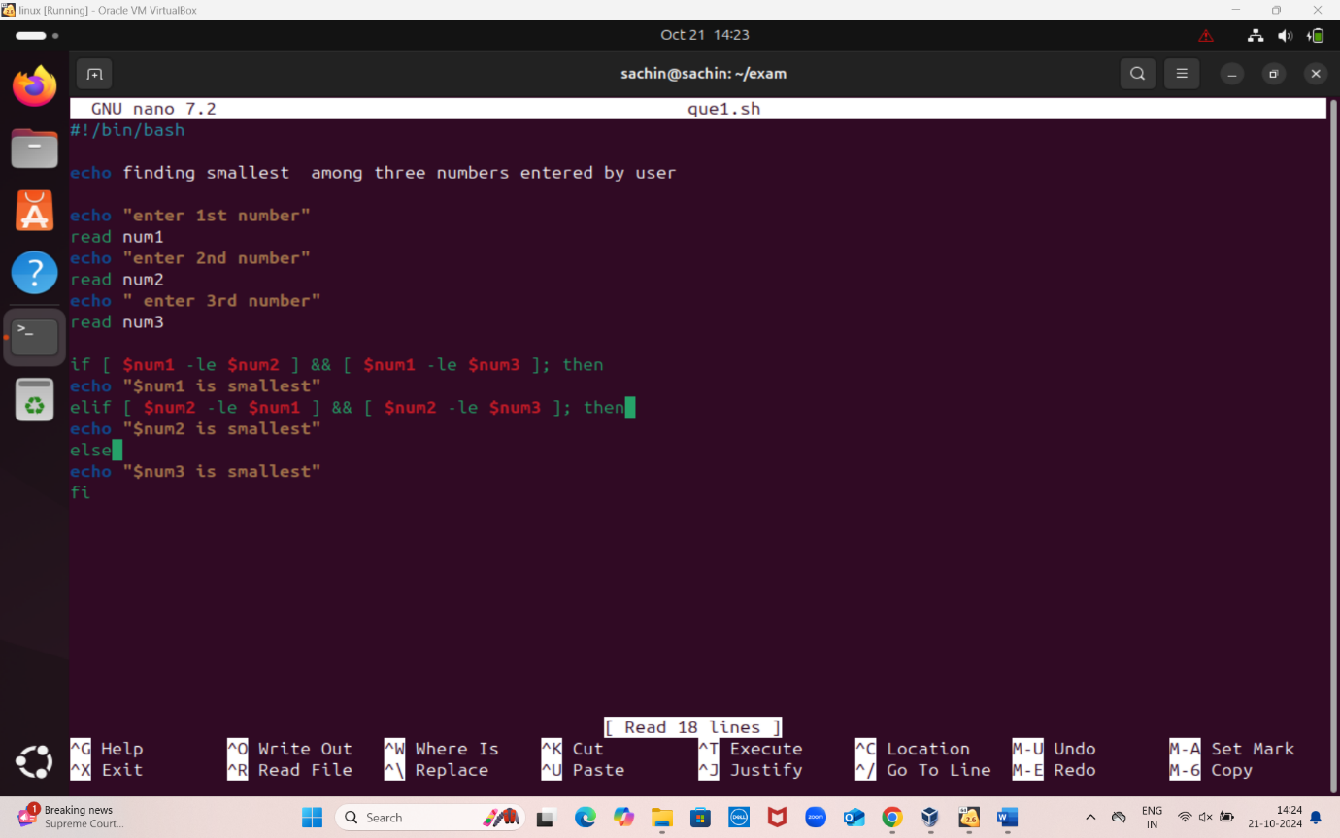

Script for smallest

**Echo finding smallest among three numbers entered by user**

**Echo “enter 1st number”**

**Read num1**

**Echo “enter 2nd number”**

**Read num2**

**Echo “enter 3rd number”**

**Read num3**

**If [ $num1 -le $num2 ] && [ $num1 -le $num2 ]; then**

**Echo “ $num1 is smallest”**

**If [ $num2 -le $num1 ] && [ $num2 -le $num3 ]; then**

**Echo “ $num2 is smallest”**

**else**

**Echo “ $num3 is smallest”**

**Fi**

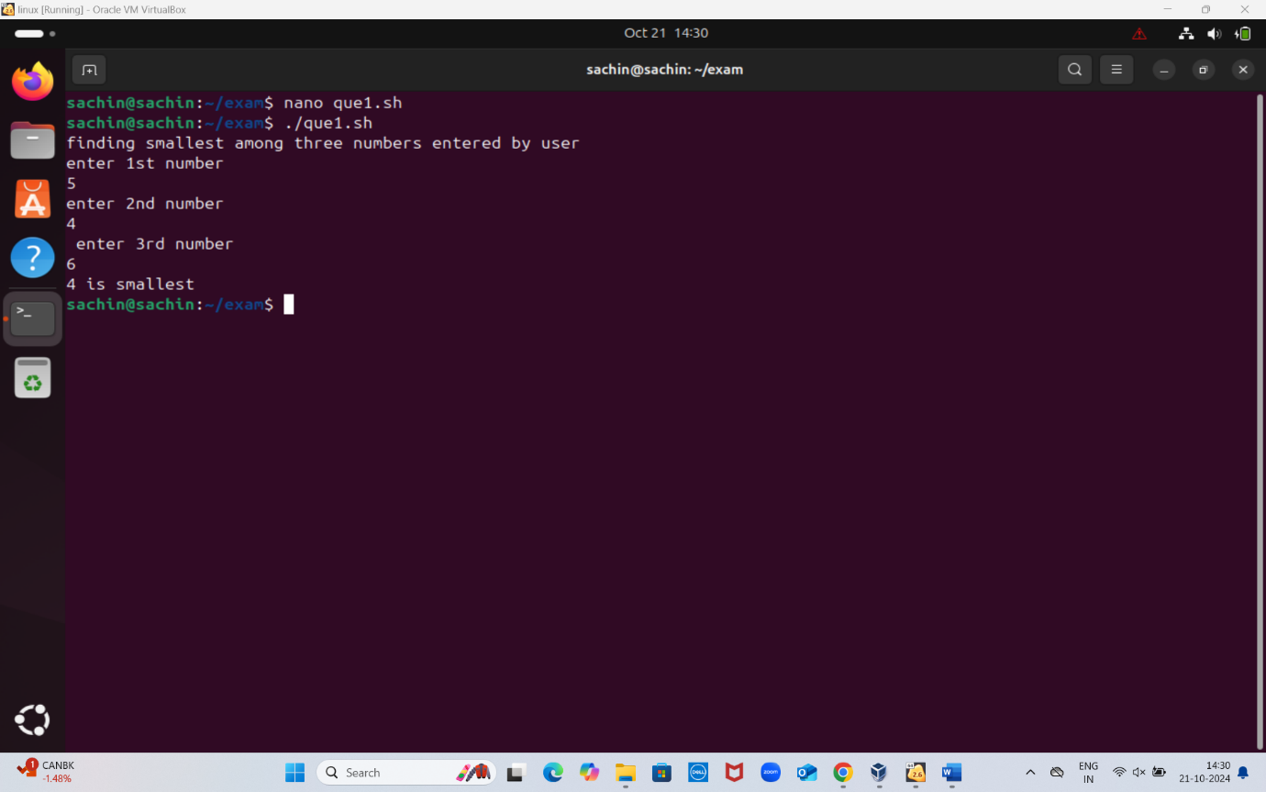

**we entered 3 numbers manually**

* **5**
* **4**
* **6**
* **Out of which smallest is 4** 
  1. Find the average of three numbers

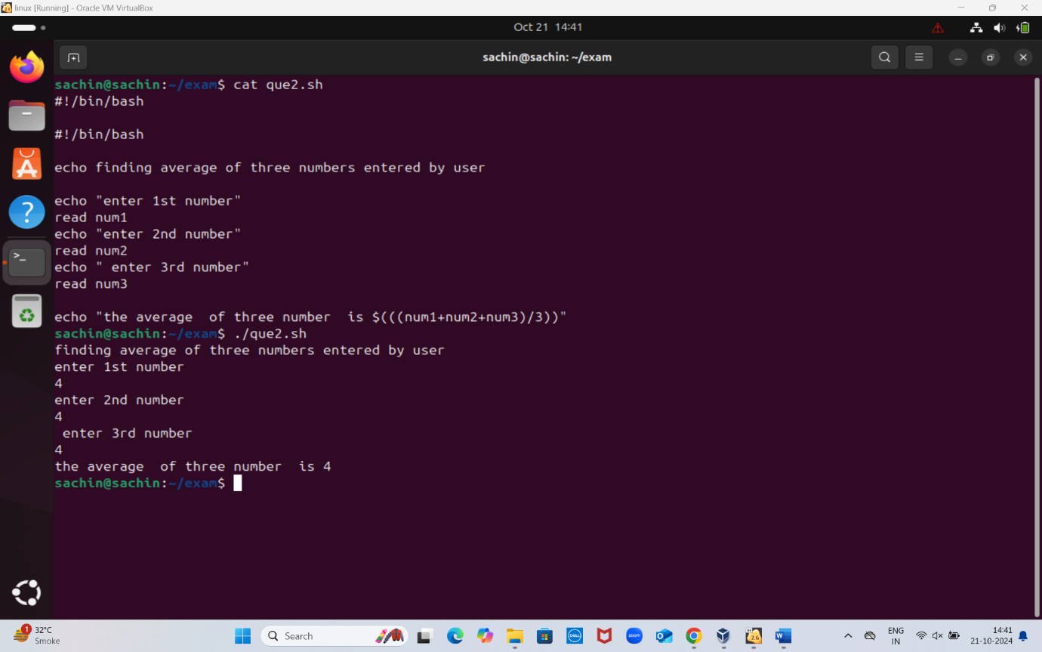

**Echo finding smallest among three numbers entered by user**

**Echo “enter 1st number”**

**Read num1**

**Echo “enter 2nd number”**

**Read num2**

**Echo “enter 3rd number”**

**Read num3**

**Echo “ the average of three number is $(((num1+num2+num3)/3))”**

**Output is**

**finding smallest among three numbers entered by user**

**num1**

**4**

**Num2**

**4**

**num3**

**4**

**the average of three number 4**

* 1. Calculate the sum of square of three numbers

**QUESTION 2: file ad directory**

**2.1 – create a new directory with a specified name**

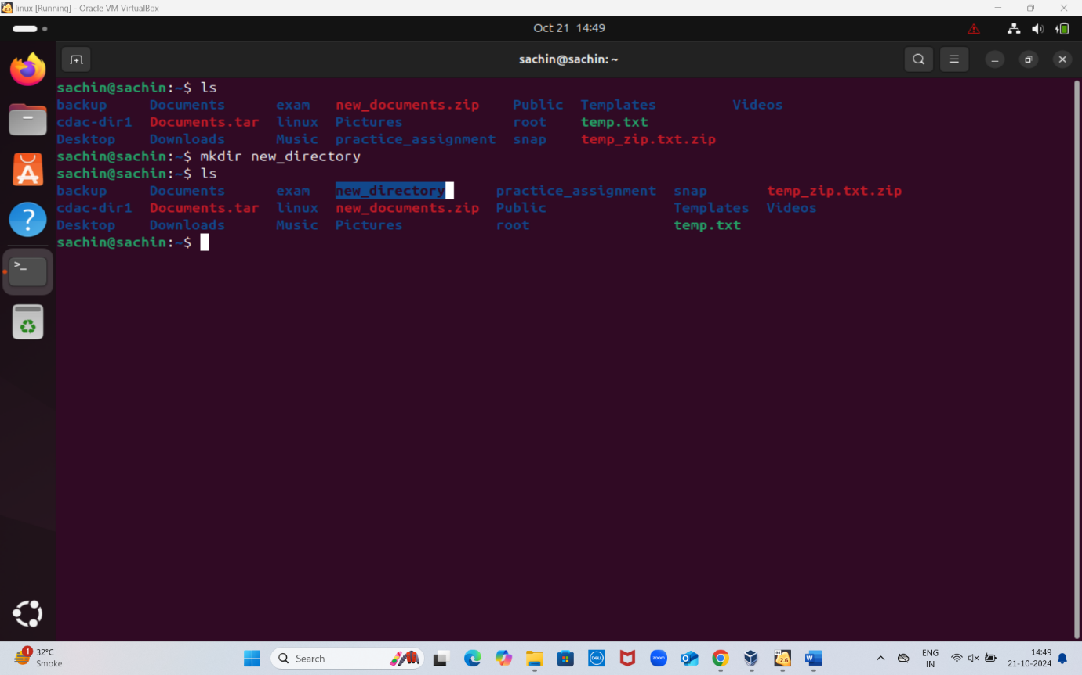

Created a new directory using

**mkdir new_directory**

And displayed all the directory using **ls**

**2.2 – rename a existing directory using new name**

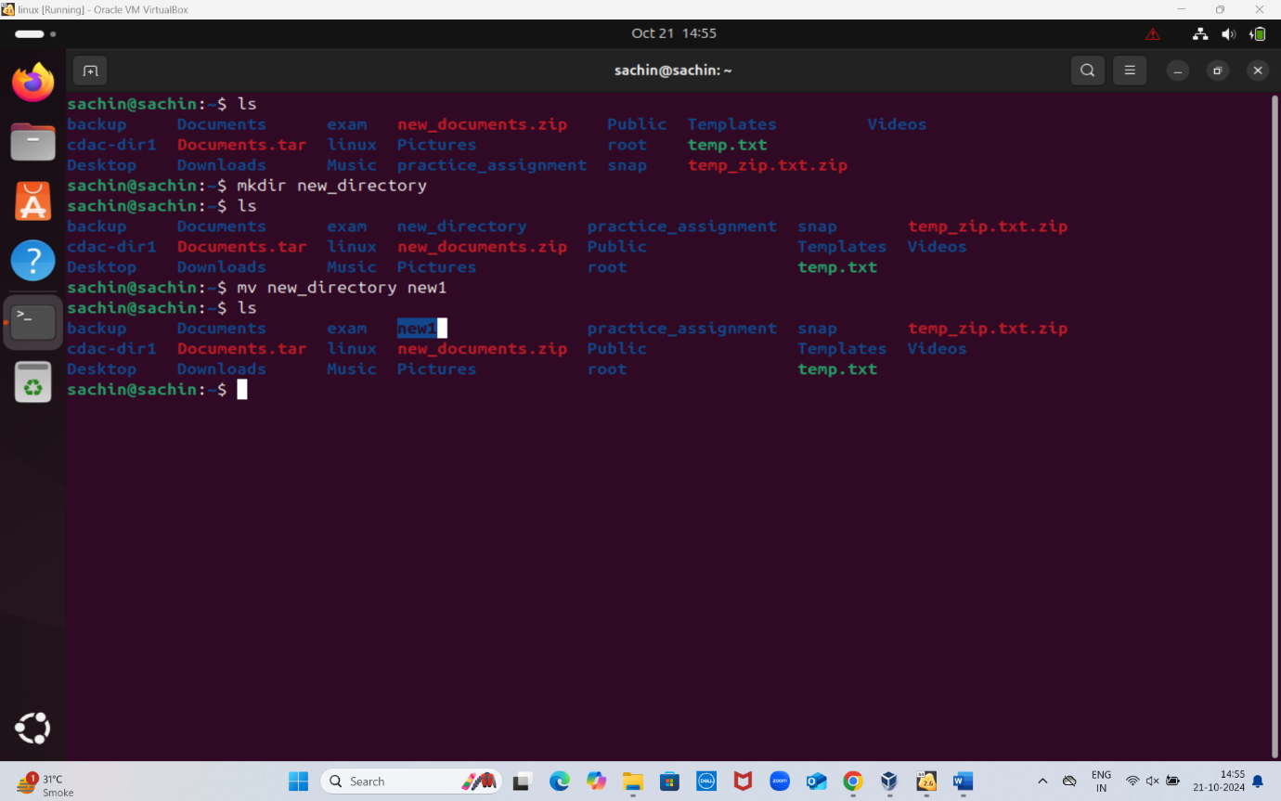

**mv new_directory new1**

mv command is used to change the name of **new_directory** to **new1**

**2.3 – move an existing to a new location**

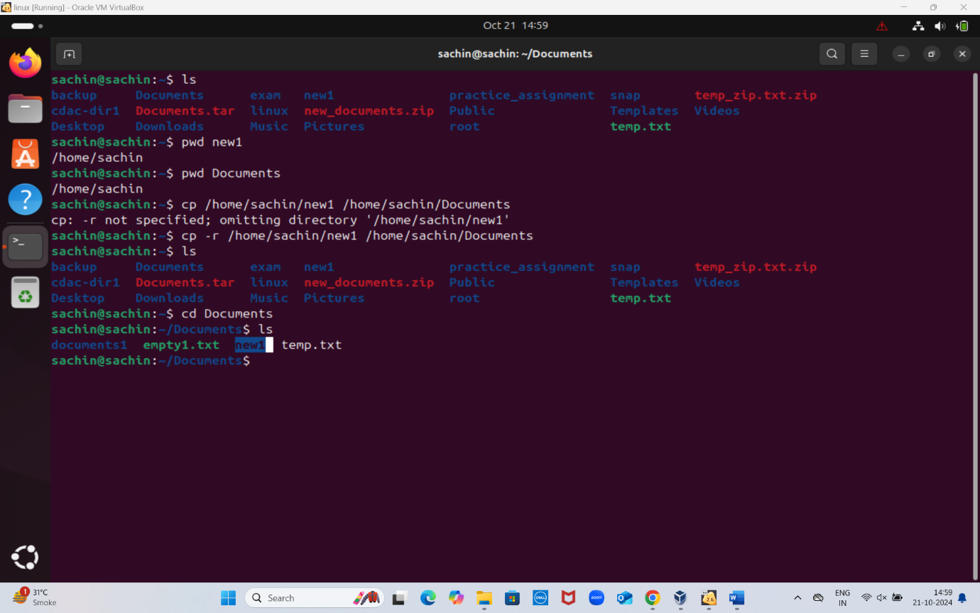

Moving a directory **new1** by copying it to new directory **Documents**

**cp -r /home/Sachin/new1 /home/Sachin/Documents**

**2.4 – delete an existing directory**

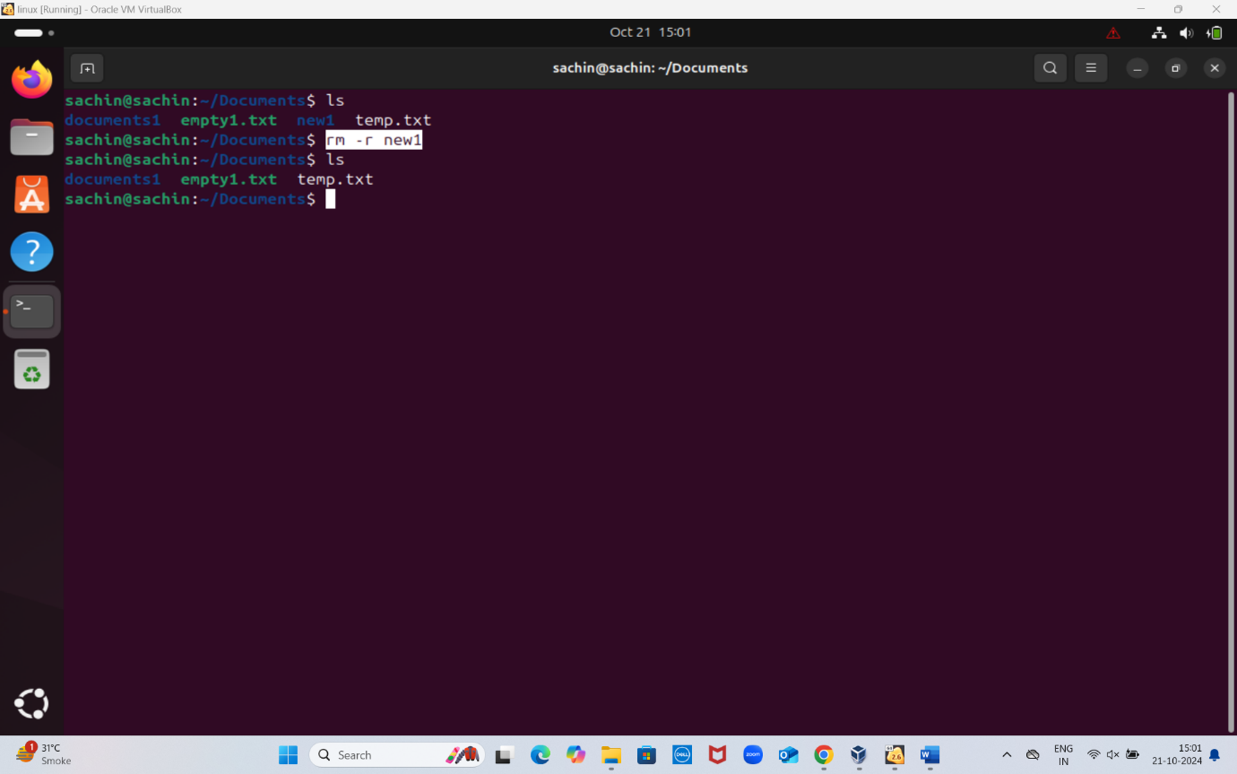

Removed a directory name **new1** from **Documents** directory using below commans

**rm -r new1**

**2.5 – create a new file in a specified directory with a specified name and give read write permission to user group**

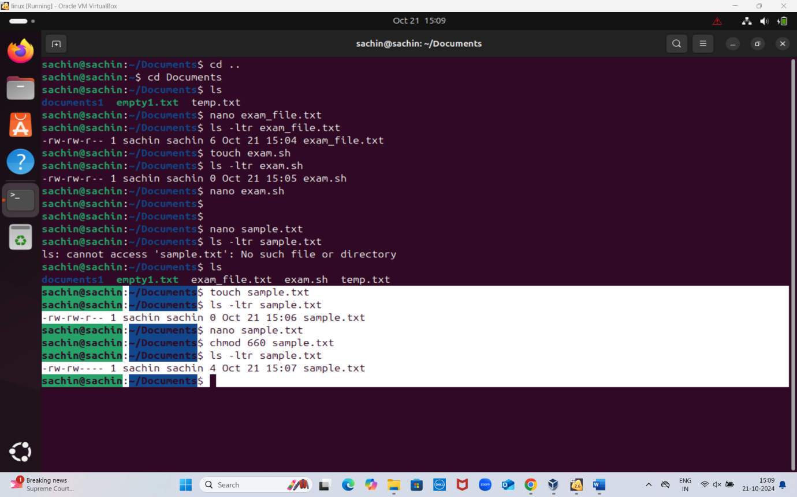

**nano sample.txt**

**Ls -ltr**

**chmod 660 sample.txt**

**ls -ltr**

**# note chmod 660 has change the persmissions**

**CLOUD**

**Que**

Creating a secure and functional cloud infrastructure using AWS

**Login to aws**

**Search for IAM**

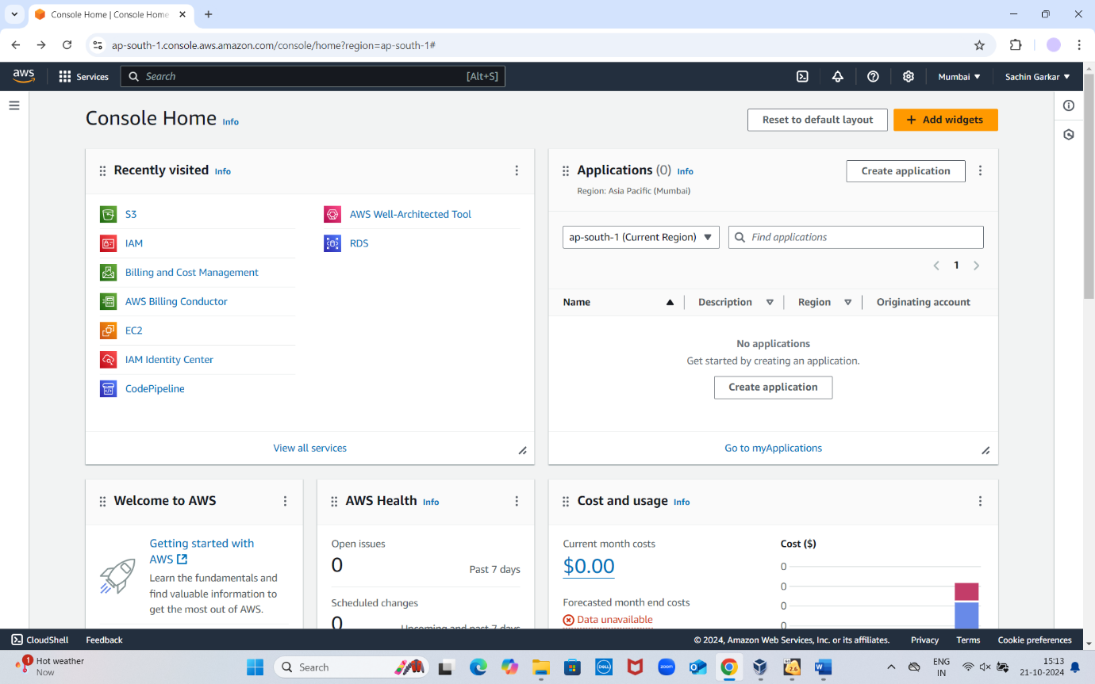

**Step - On I am dashboard left hand bar has users click on users**

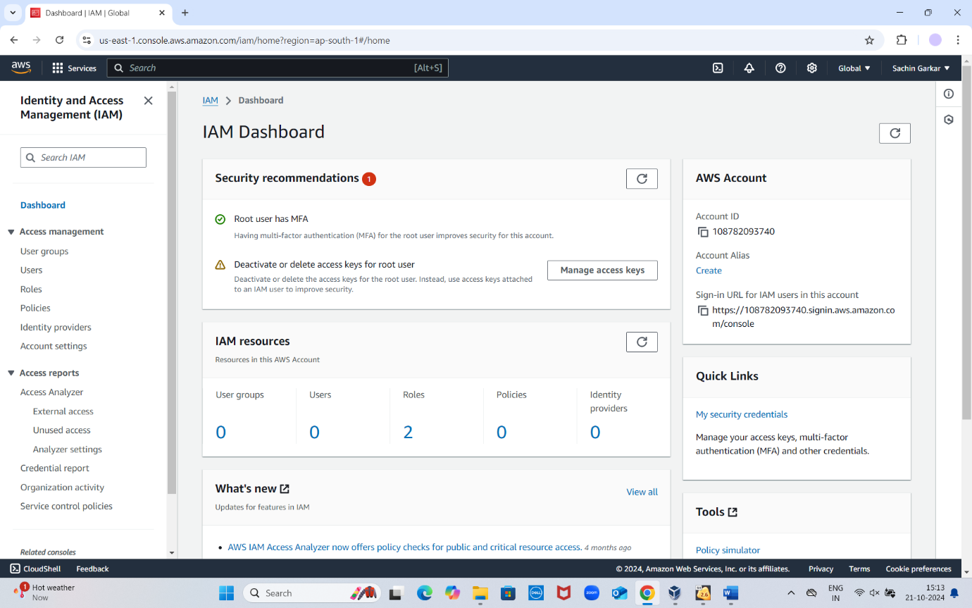

**Step – click on create user to create new user** 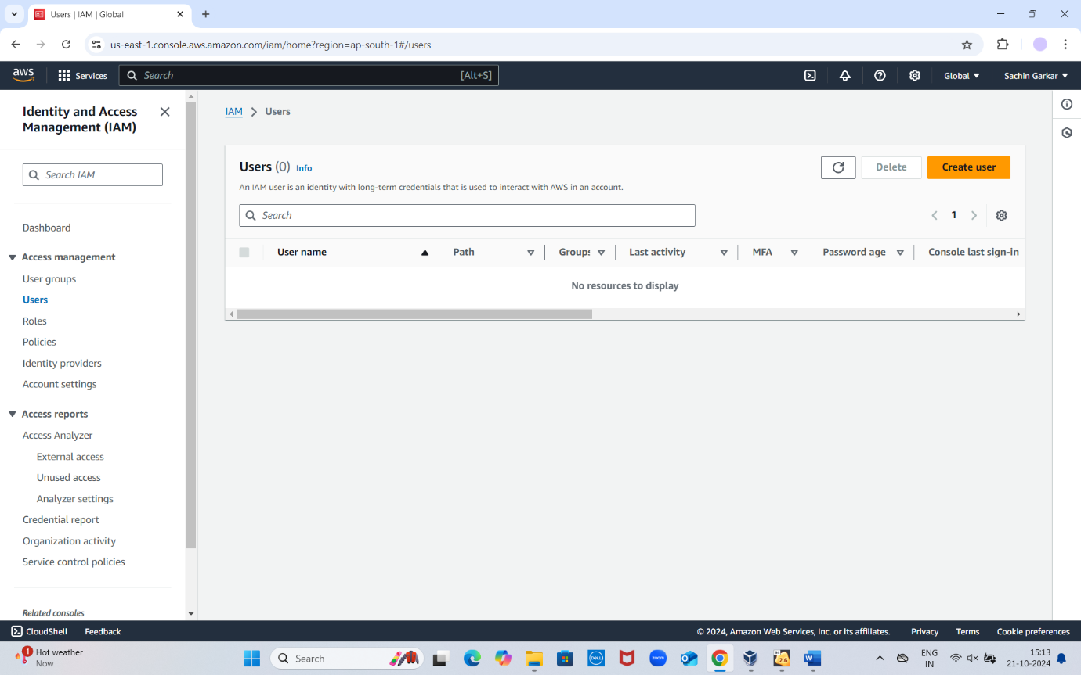

**Step – given name to user newexamuser and check box**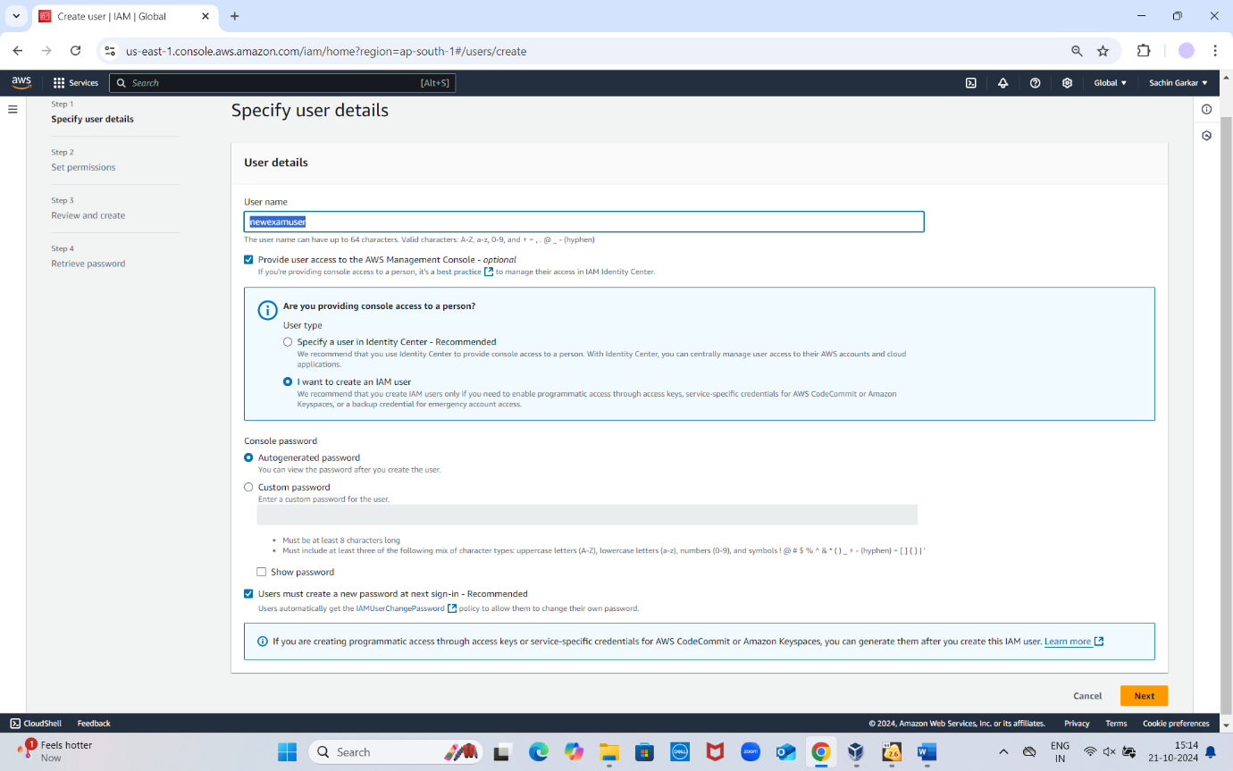

Step – click next to proceed further

Step – set permisssions and policies whether add user to group and add the policies to give permission to access or not and click on next

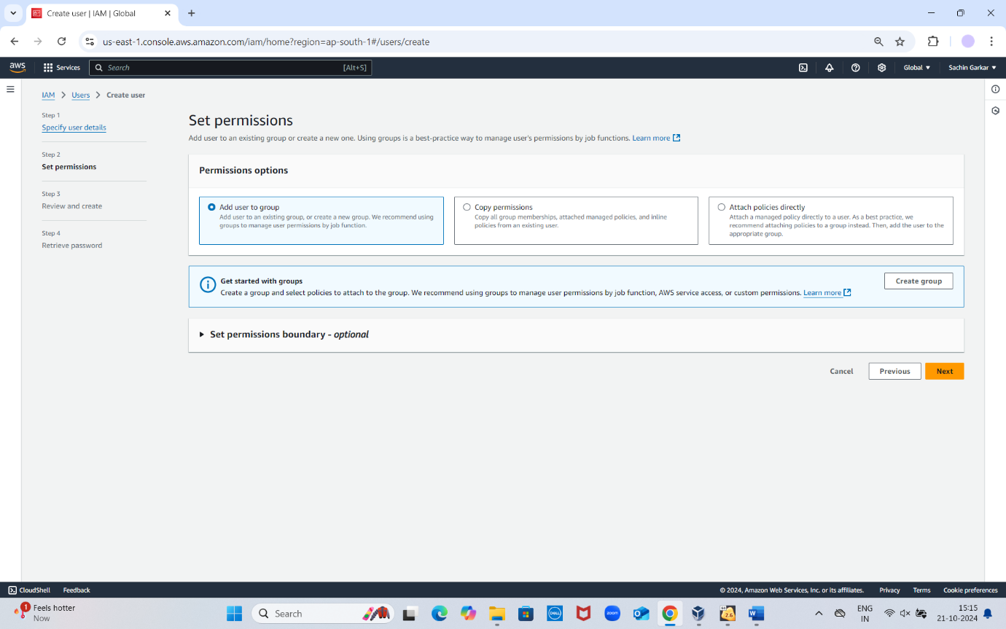

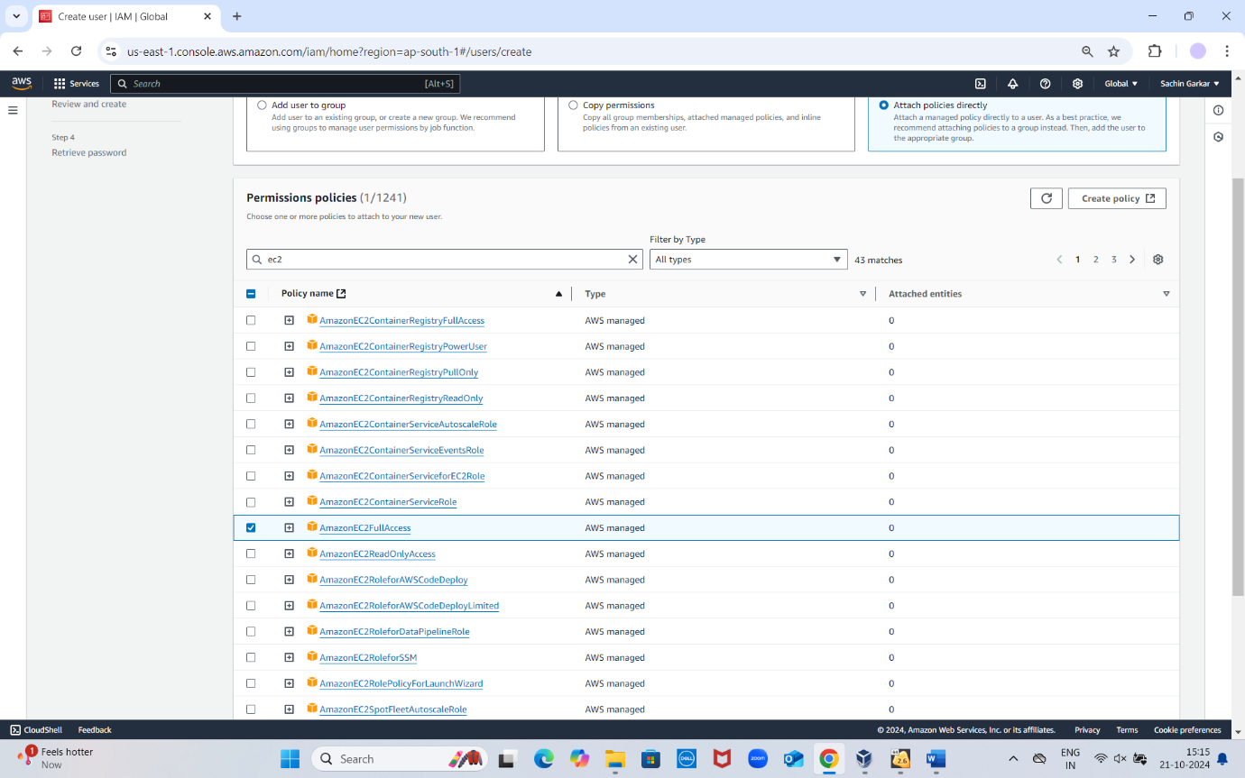

**Sterp - granted full access**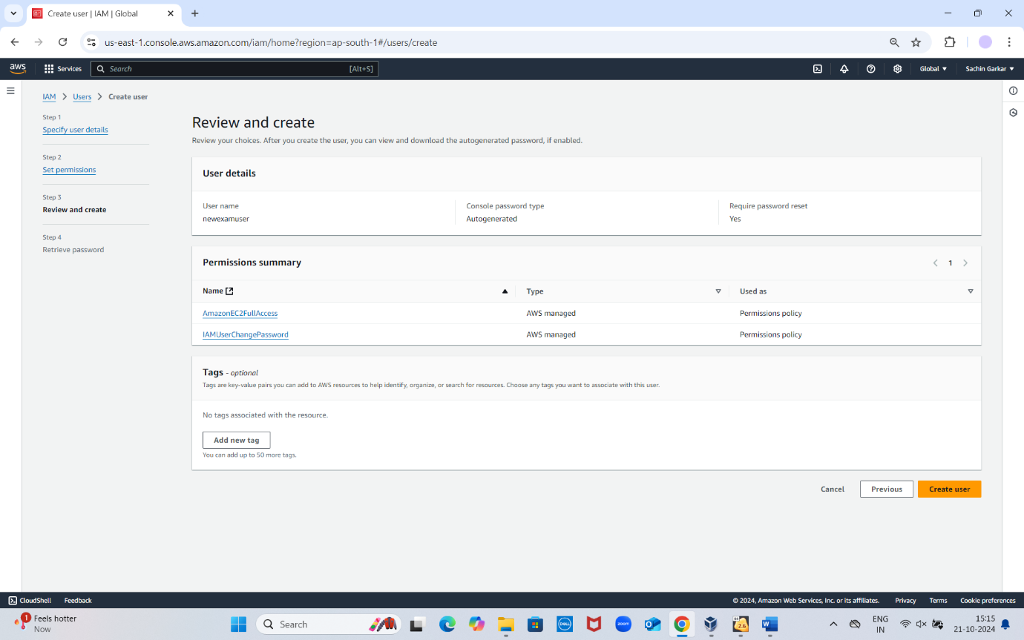

**Step – usre created successfully**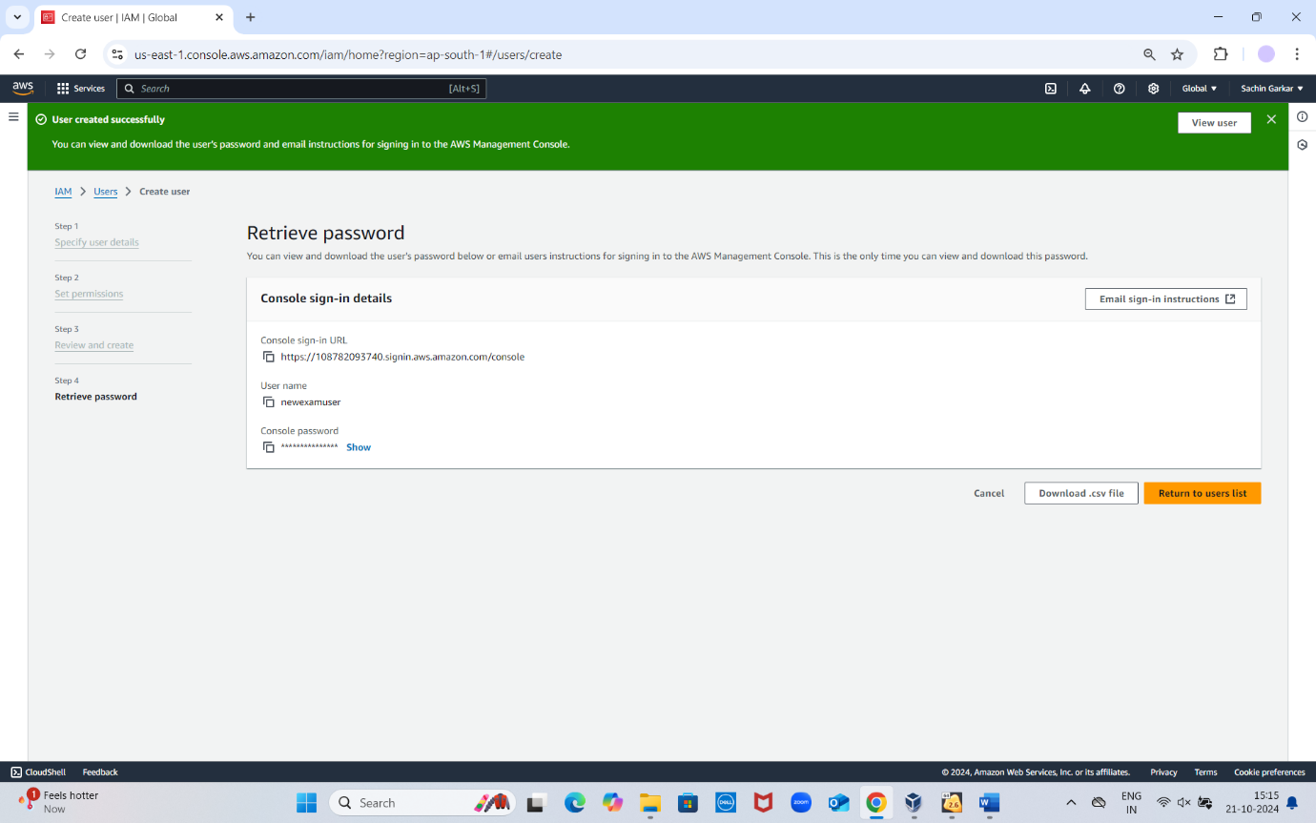

**Step – we can see a user with policies creted in identity and access amangement**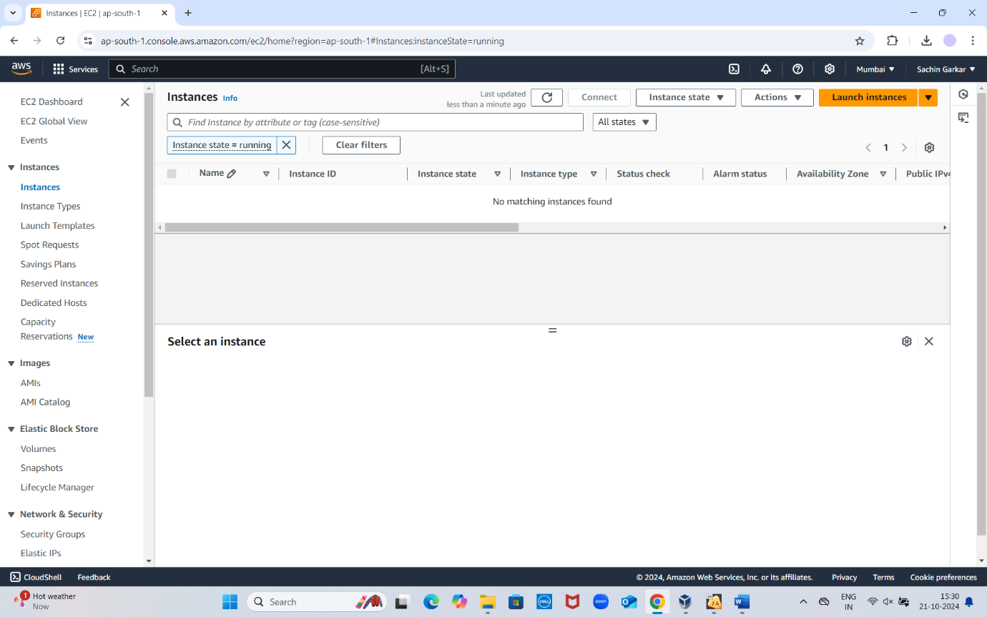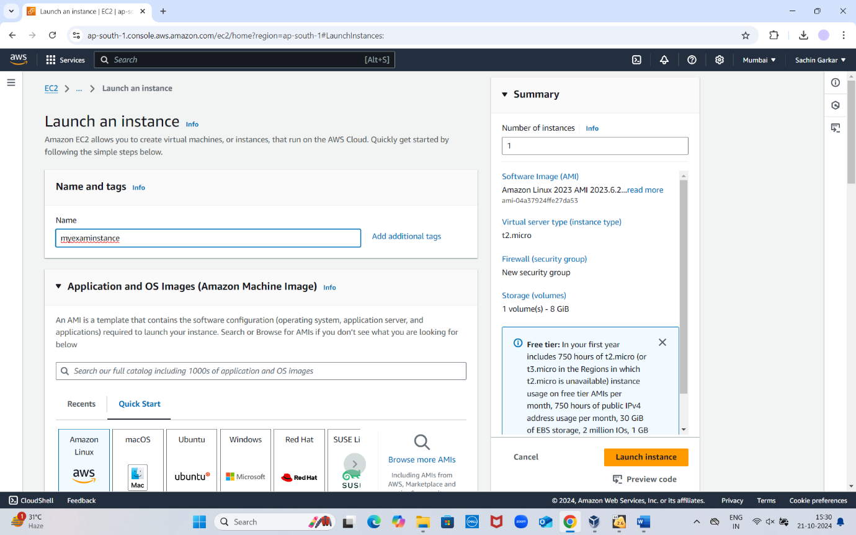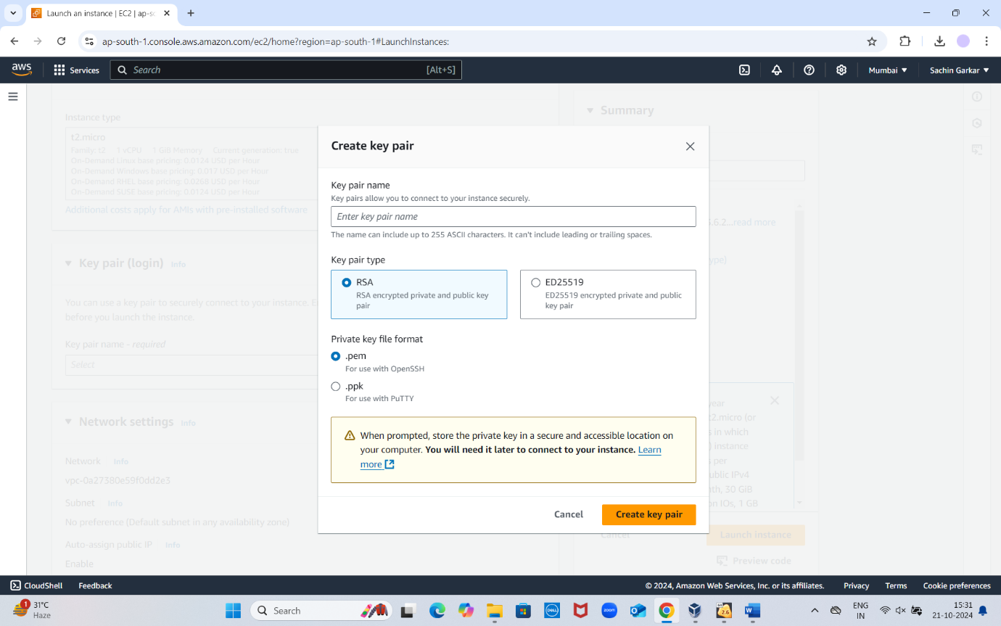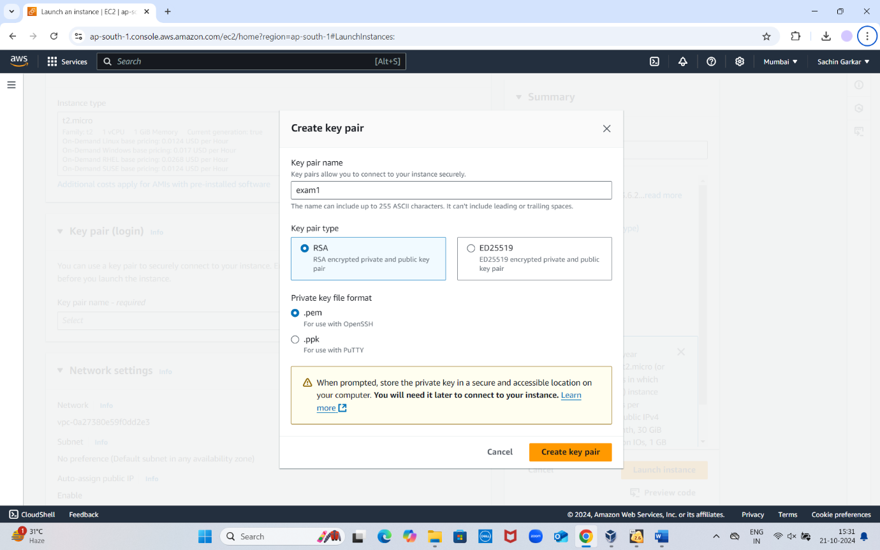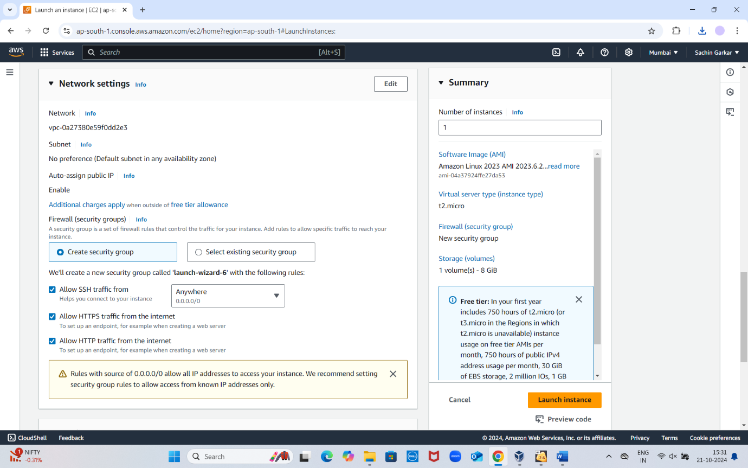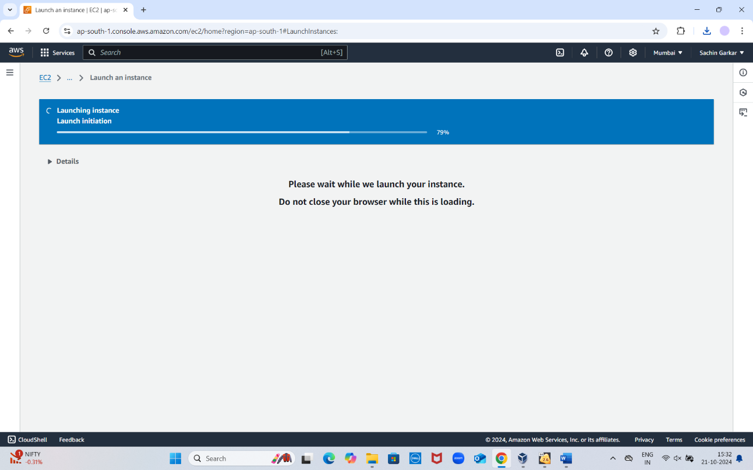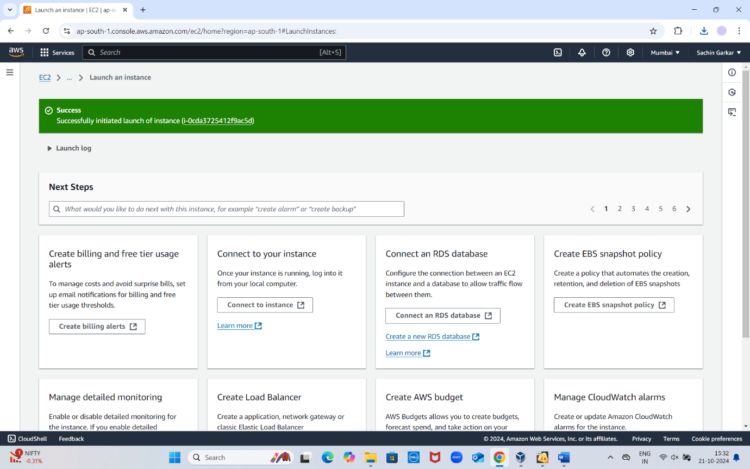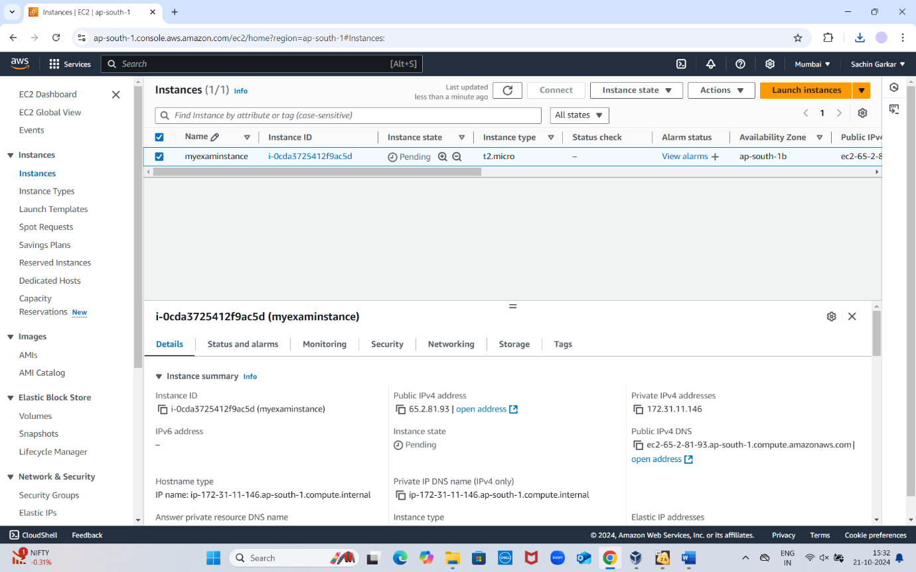

**In the above process EC2 instance is created now we will create S3 bucket**

**Creting a s3 bucke to launch static web page**

**Created a bucket with name myexambucket-1223**

